CV
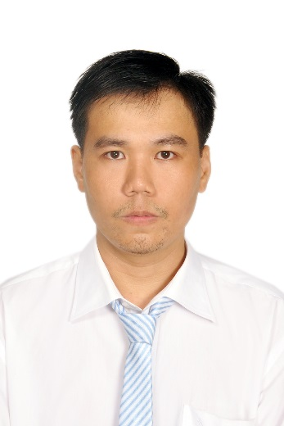

Lê Quý Ái

1. Personal information:

- Gender: male & single
- Age: 35 (Year of birth: 1984)
- Living at: 107, number 30 street, Bình Phú residential quarter, ward 10, district 6, HCMC
- Phone: 0937191973
- E-mail: ktlqai@gmail.com

- Acedamic degree: Bachelor of Mathematics & Computer Science, HCMC University of Natural Sciences. With the graduation mark of 7.01

2. Experience:

- I did not feel easy with people since 2002 (the time I just finished high school & entered university). So after my university graduation (March 2008), I was so hard to work with colleagues. I joined several software companies but I quitted all of them after just working for them about 1 month.

- After some years, I am totally out-dated & almost have no chance to work as a coder & also my attitude with people around me did not change. So I down-graded to work as a computer fixer & then I continued to down-grade again to become a factory worker. Time passed so fast & my life went along. I was so tired with the labour job & I was so stressed with people around me (even people in my family).

- In 2015, I was sick & stayed at home. I thought of my life. And I realized that I spent all of my time to studying. So I did not know much about the social life. That is the reason why I was so fragile & hated & stressed with people around me. It also explained why I hated to learn from senior colleagues. So, I did not have much experience with coding. I just coded some PHP & MySQL for a very simple CMS & a very simple online book store. That was when I worked for a small web design company named Fibo.

- In university, I also learned Java & did a small network project to simulate a music & picture files download client & server. And a small shop site with JSP.

- Now, I changed my mind to respect & stay peace with people around. I should respect & learn from senior colleagues for things they knew but I am new, and also be together with them to challenge new things. This fixes all my failured life in the past.

- So my experience in short are just basic knowledges of HTML, CSS, JavaScript, PHP, MySQL, then Nodejs, Angularjs & Reactjs.

3. Preferred job:

- I love to work with new technology stacks like Nodejs over PHP. And maybe new concepts like blockchain.

- I prefer to build websites or web applications (where I can work as front-end or back-end or both roles).

Thank you!

