PHAM HOANG THO
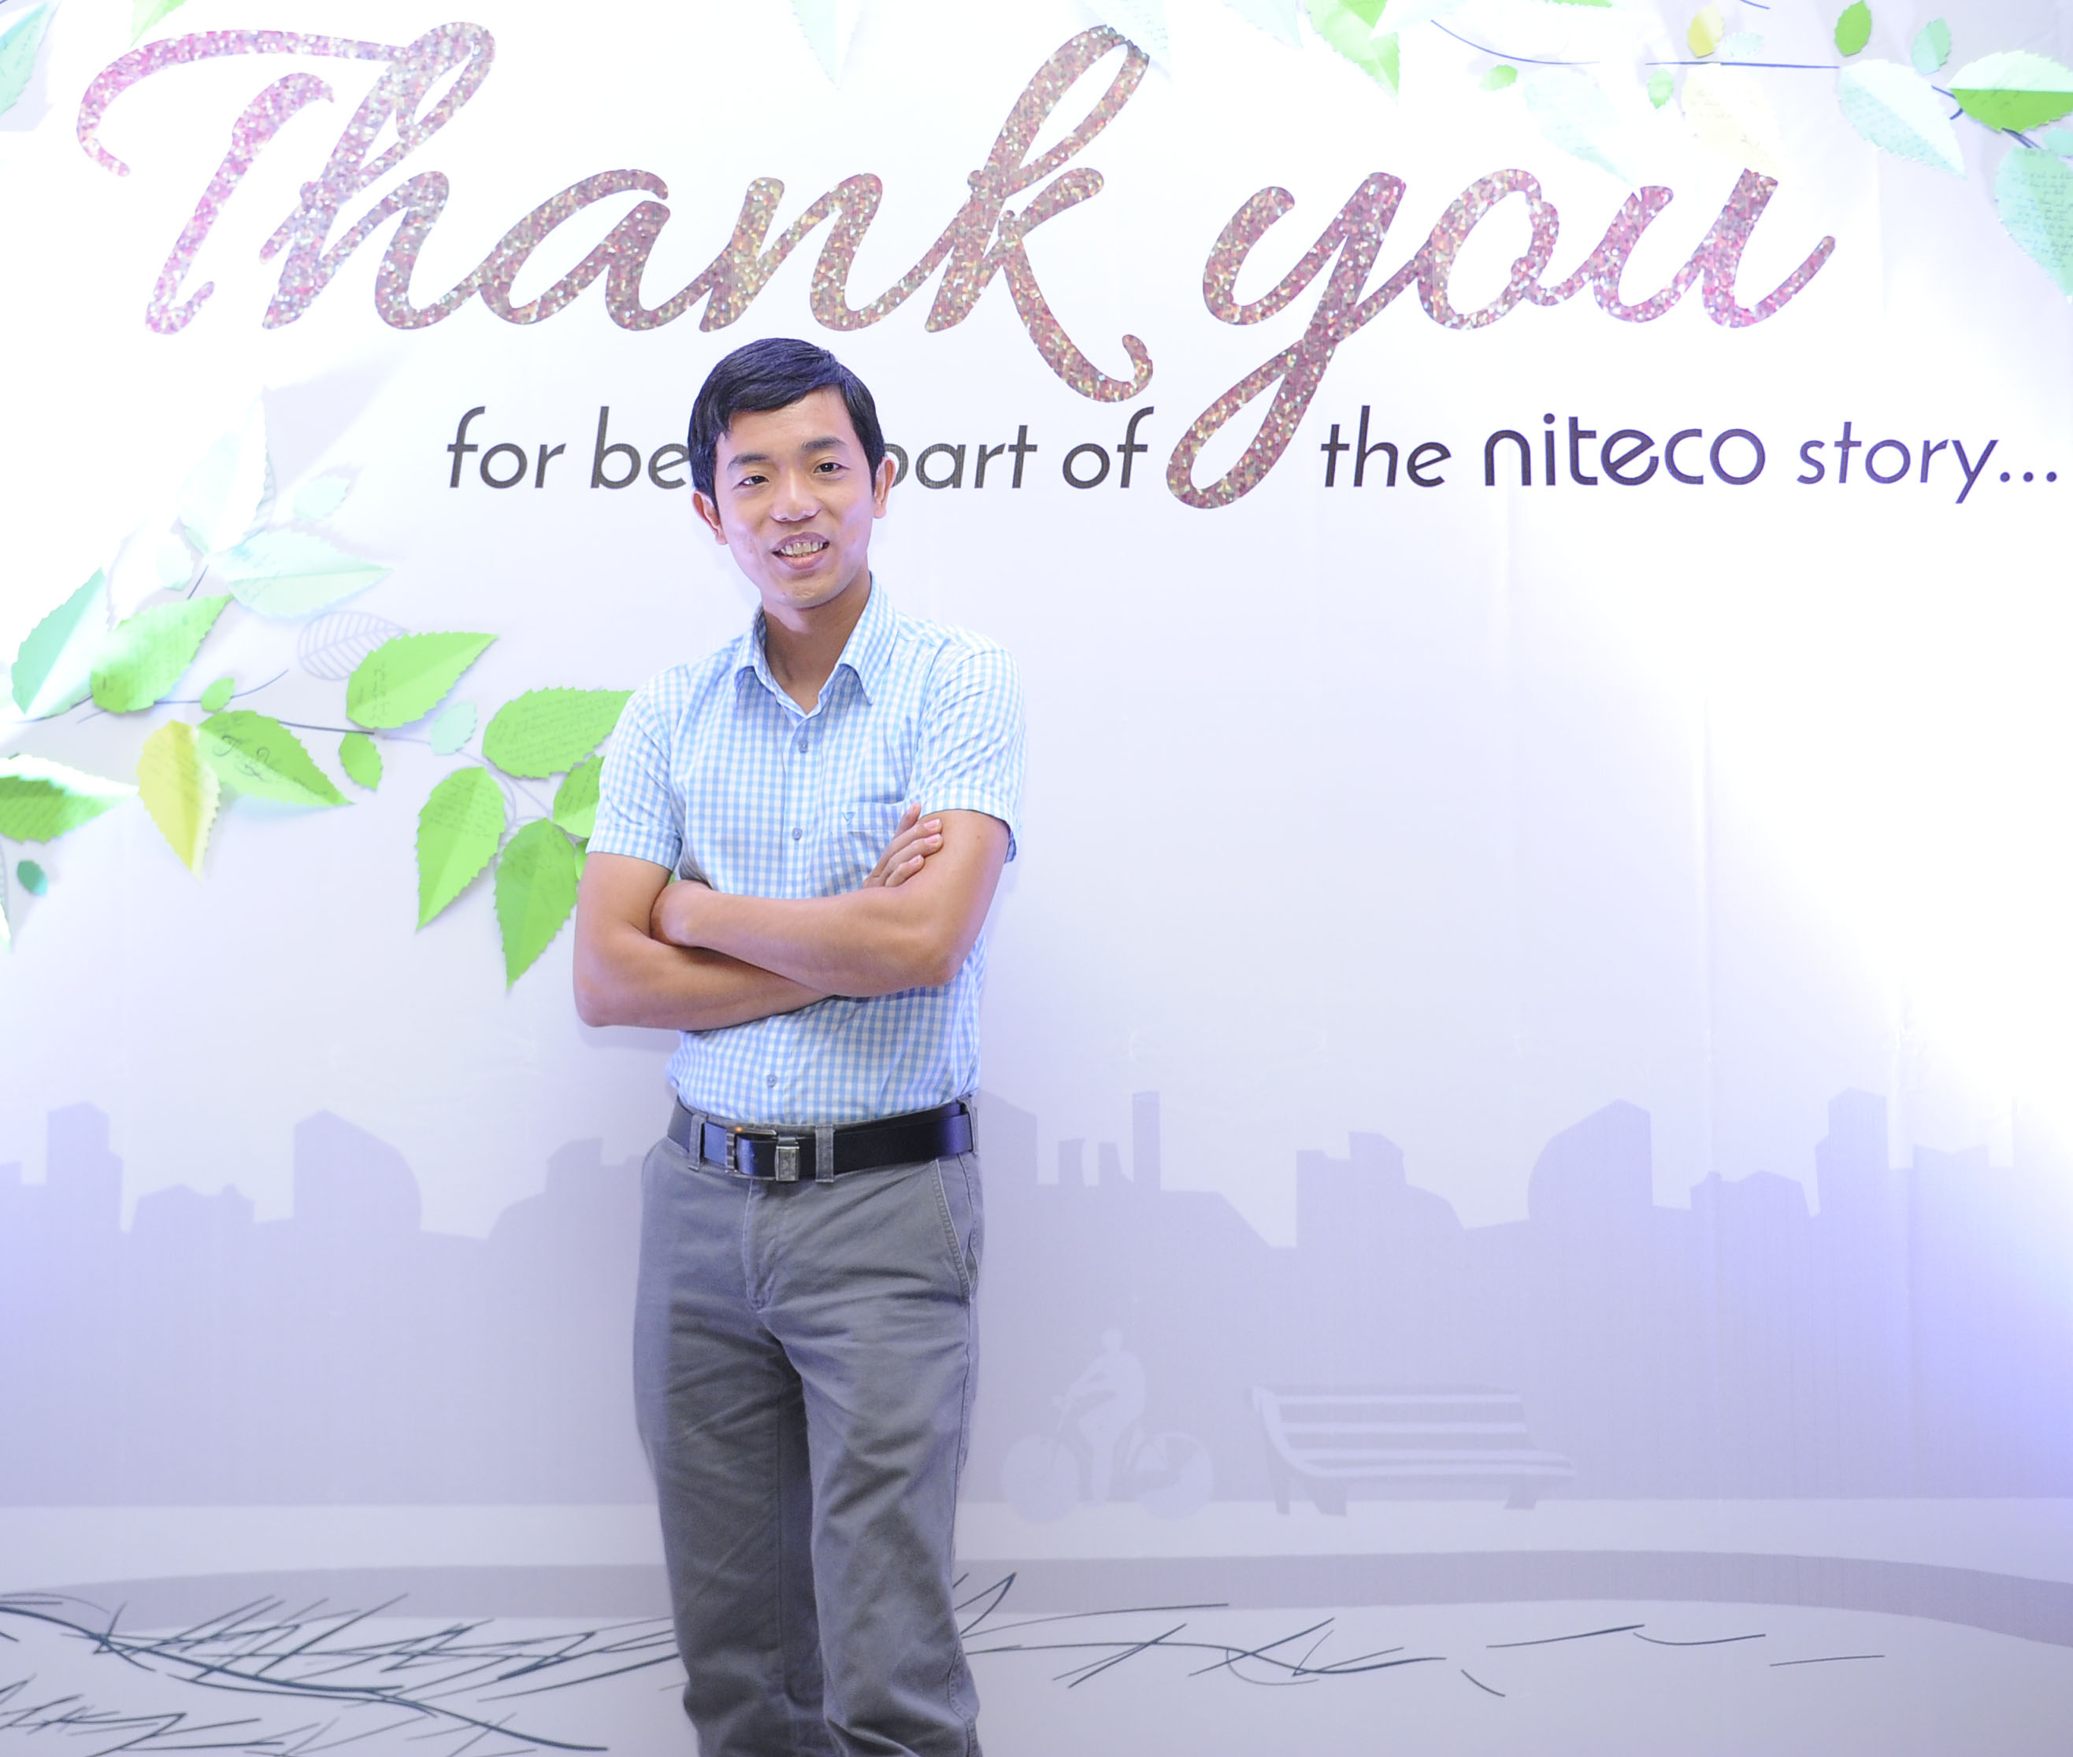
Senior Software Developer
DOB: 21/07/1989
Mobile: 0169 883 4447
Email: phamhoangtho@gmail.com

SUMMARY
A results-driven, customer-focused, articulate and analytical Senior Software Engineer who can think “out of the box”. Strong in design and integration problem-solving skills. Experienced in C#, .NET, and scripting language. Skilled in developing business plans, requirements specifications, user documentation, and architectural systems research.
Strong written and verbal communications. Interested in a challenging technical track career in an application development environment.

TECHNICAL SKILLS
- Programming languages: C#, Ruby on Rails
- Markup languages: HTML5, CSS3, JavaScript, Jade
- Frameworks/ Platforms: .NET (core), MVC, Web Services, Entity Framework (core), LINQ, JQuery, AngularJS, Knockout JS (build project with Grunt/Gulp), ReactJS, Bootstrap, EPiServer, Sitecore (beginner)
- Database Management Systems: MS SQL, MySQL, MongoDB
- IDEs: Visual Studio, Visual Studio Code, SQL Management Studio, My SQL Workbench, RoboMongo, WebStorm, Sublime Text.
- Operating systems: Windows
- Source Control: SVN, GIT, TFS.
- Foreign languages: English
- Management skills: Listening, subject matter knowledge, using project management tools, leadership skills, time management, communication
- Soft skills: Interpersonal, Team spirit, Negotiation, Behavioral traits such as attitude, motivation and time management
- Architectures: Onion, Microservces

EDUCATION
- Qualifications: MCPD, TOEIC 700, EPiServer Certified
- InfoWorld – InfoWorld School Certified Professional
- Asia E University (Malaysia) – Bachelor’s Degree

PROFESSIONAL EXPERIENCE
October 2016 – Present – Amaris
Amaris is an international Technologies and Management Consulting Group with more than 60 locations around the world. We have teams working together from many countries over the world.

Project that I’m working on:
I’m taking responsibility to build web application to automate salary calculation
Frameworks and tools I’m using:
- ASP.NET MVC Framework 5
- Entity Framework 6
- MSSQL Server 2014
- Javascript and Jquery
- Boostrap
- TFS build, GIT

Dec 2015 – October 2016 – Niteco Vietnam
Senior Software Developer
Project: KTM
Project Description: build Web application with EPiServer CMS, JQuery and use Jade framework for making page template; CSS3 for marking up UI; SQL Server for storing data.
Responsibilities:
- Receive and analyse tasks.
- Communicate with team members.
- Develop new features and fix bug.
- Work as a Front-End developer

Feb 2015 – Oct 2015
Working as Freelancer at night
Project: Work for Australian customer
Project Description: build Web application with JavaScript, AngularJS, JQuery, NodeJS, HTML & CSS for marking up UI, MongoDB for storing data.
Responsibilities:
- Receive and analyse tasks.
- Communicate with customer.
- Develop new features and bug fixing.

Oct 2014 – Dec 2015 – FPT Software
Software Developer
Project: PERPERUNA & HEDI
Project Description: build Windows Form application, Excel tool and library using C++ to support customer calculate Hourly Price Forward Curve. Hourly Price Forward Curve (HPFC) is the forward price vector constructed from historic spot settlement prices and current liquid forward standard products. It can be viewed as an expected spot price evolution according to the actual market perception about the future price levels. The accurate determination of future hourly prices is of extreme importance, since it directly affects an offer quoted to a client as well as the portfolio fair value.
Responsibilities:
- Collect and analyse the requirements.
- Design database and UI.
- Develop new features and bug fixing.
- Communicate directly to Model Developer to clarify requirements.

Nov 2013 – Oct 2014 – FPT Software
Software Developer
Project: Atlas
Project Description: build website with MVC Framework.
Responsibilities:
- Collect and analyse the requirements.
- Design database and UI for website.
- Develop new features and bug fixing.

Software Developer
Project: PFG
Project Description: build and maintain the windows application using WPF Framework.
Responsibilities:
- Collect and analyse the requirements.
- Design database and UI for website.
- Develop new features and bug fixing.
Technologies Used: .Net framework 3.5, C#, WPF and MVVM Framework

Software Developer
Project: Simulator
Project Description: the project is research program about new technologies for applying to project.
Responsibilities:
- Research the new technologies.
- Conduct the training and transfer research result to another team member.
Technologies Used: .Net framework 3.5, C#, Windows Workflow Foundation, Caliburn Micro Framework, Managed Extensibility Framework

Software Developer
Project: MIS-MEN
Project Description: the project is an internal tool which support HR to manage and organize human resource.
Responsibilities:
- Collect and analyse the requirements.
- Design database and UI for website.
- Develop new features based on the requirement.
- Do bug fixing.
Technologies Used: SharePoint 2010 and 2013, .Net framework, C#

Mar 2013 – Nov 2013
Freelancer/Project Manager at home
Project Description: Build and design website for customer.
Responsibilities:
- Communicate with customer to get requirements.
- Plan to release project’s proposal.
- Design database and UI for website.
- Coding.
Technologies used: ASP.NET MVC, LINQ, Bootstrap, CSS3, JavaScript

May 2012 – Feb 2013 – FPT Software
Software Developer
Project: XR
Project Description: Worked on multiple projects of Hitachi Medical customer
Responsibilities:
- Joined full life-cycle of software development
- Coding
- Fix bugs.
- Create test cases, execute unit test.
- Review check list in order to ensure the product’s quality.
Technologies used: Delphi, VC6.0, VC++

Sep 2011 – Mar 2012 – Infonam
SQA Engineer – Developer

Project Description:
Worked on project name “Snapstick”, this application was built with Objective C and Java, It could be run on iOS, Android mobile devices such as tablets, smart phones.
Responsibilities:
- Coding Javascript
- Fix bugs
- Create, review, validate and maintain comprehensive regression test suite.
- Execute regression test suite and report results and issues timely and accurately.
- Ensure that test case standards are adhered for all test cases included in regression suite.
Technologies Used: JavaScript, Objective C, Java

