CURRICULUM VITAE

PERSONAL INFORMATION
Full Name: Hoang Chau Khanh | Date of Birth: 18th May 1993
Nationality: Vietnam | Gender: Male
Phone : +84 163 9787 427
Email: hoangchaukhanh93@gmail.com
GitHub: https://github.com/hckhanh
LinkedIn: https://www.linkedin.com/in/hckhanh
Skype: hoangchau_khanh

ACADEMIC CERTIFICATIONS
- Bachelor of Information Technology, University of Science Ho Chi Minh City
(2011 – 2015)

SOFT SKILLS
- Teamwork
- Fast-learning
- Independent research
- Listening
- Problem solving

EXPERIENCE SUMMARY
- Possesses good knowledge of HTML, JavaScript, CSS, React.js, Bootstrap
- ~2-year experience of React.js
- ~3-years experiences of Node.js

TECHNICAL PROFICIENCY
Design Tools | Photoshop, Sketch
Languages | JavaScript, Java, UML, Ruby
Operating Systems | Windows, Linux (Ubuntu, CentOS 7), Mac
Database | MongoDB, MySQL, SQL Server, PostgresSQL
Application servers | Apache Tomcat, Heroku, Eclipse
IDE | Visual Studio, WebStorm
Frameworks | Express, Loopback (Node.js), React.js
Code Editor | Sublime, Atom, Visual Studio Code
Continuous Integration | Travis, Bamboo
Issue Tracking and Project Management | JIRA, Pivotal Tracker, YouTrack, Mantis Bug Tracker
CSS Frameworks | Sass, Less

Experience
Software Engineer at Robert Bosch Engineering and Business Solutions Vietnam Company Ltd
November 2015 – December 2016 (1 year)
React.js Developer at 2359 Media Pte Ltd
December 2016 – February 2017 (3 months)
Relia Systems
May 2017 – October 2017
Freelancer
January 2018 – February 2018
Full-stack Developer at Alley 51 Ventures
May 2018 – September 2018

WORKING PROJECTS
No | Projects | Description
1 | Project Name | CoSMoS
 | Project Position | UI Designer and Android Developer
 | Team Size | 2
 | Project Description
 | Description | CoSMoS is Cold Storage Monitoring System. It is designed to monitor & control the cold  storage via web server or mobile application. It will help in reducing operating cost of cold  storage owners by reducing electricity load & manual labor. This document will provide  detail software requirement for CoSMoS mobile app.
 | Technical Environment
 | Technologies | Android
 | Development Tools | Android Studio, Git, JIRA, Gerrit, Photoshop CC
 | Programming language | Java
 | Images | 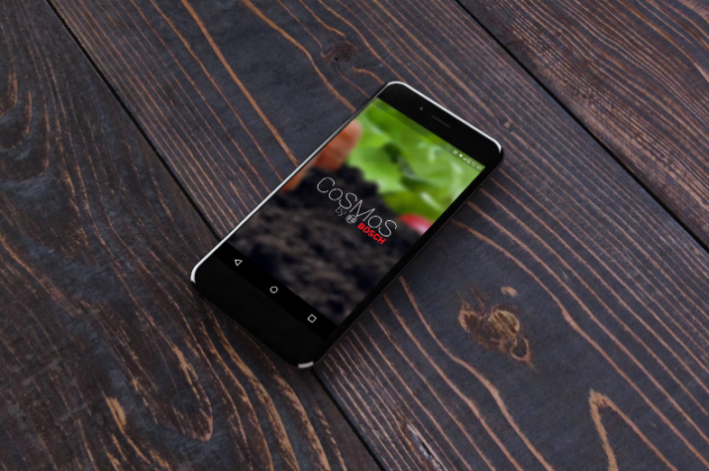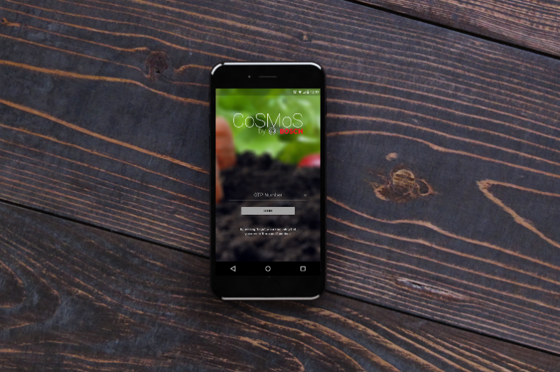
2 | Project Name | WAPO
 | Project Position | Develop and maintain the application and design login screen
 | Team Size | 4
 | Project Description
 | Description | WAPO is a water management system allow user can get report data from water sensors to measure the amount of water which is used of many departments in a building. User can get the reports of the water usage of month or year. I designed the login screen using Photoshop by myself. I feel good about color.
 | Technical Environment
 | Technologies | Android
 | Development Tools | Android Studio, Git, JIRA
 | Database | MySQL
 | Programming Language | Java
3 | Project Name | Seat Tracking
 | Project Position | Web Developer
 | Team Size | 3
 | Project Description
 | Description | Seat Tracking is an application allow company to manage working place of employees including all assets. This system is useful for HR department to manage employees and their assets. If some assets are missing, HR department can view the history of the lost assets and find out who lost those assets.
 | Technical Environment
 | Technologies | Web
 | Framework | React.js
 | Development Tools | Sublime, Git, JIRA, Semantic-UI library
 | Database | MySQL
 | Programming language | JavaScript
4 | Project Name | Map Simulation
 | Project Position | Web Developer
 | Team Size | 3
 | Project Description
 | Description | Map Simulation is a content management system for mineral deposits in Indian. The application will load the data from customer APIs and draw the information of the mines on the map. This information is displayed by points, circle and polygons. User can add more or remove points, polygons and circles to the database by interacting with the map. The map library is used is OpenLayers.
 | Technical Environment
 | Framework | React.js
 | Development Tools | Visual Studio Code, Git, JIRA, Material-UI library, OpenLayers 3
 | Database | PostgresSQL
 | Programming language | JavaScript
5 | Project Name | FOX+
 | Project Position | Web Developer
 | Team size | 10
 | Project Description
 | Project Link | https://www.foxplus.com
 | Description | FOX+ is a media service of Fox Broadcasting Company. This is a big system allow users can view the content of Fox’s channels including paid services. This service is a part of Fox’s ecosystem.
 | Technical Environment
 | Framework | React.js
 | Development Tools | WebStorm, Pivotal Tracker, GitHub, Travis CI
 | Database | MongoDB
 | Programming language | JavaScript
 | Images | 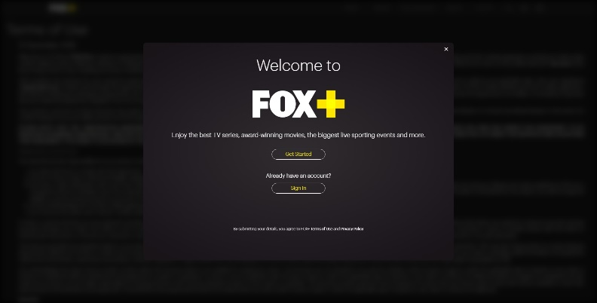
6 | Project Name | Campus
 | Project Position | Web Developer
 | Team size | 1
 | Project Description
 | Project Link | https://campus-stage.herokuapp.com
 | Description | This is a reference website for schools in United Arab Emirates. User can look up information of the schools of Arab’s emirates.
 | Technical Environment
 | Framework | React.js, Rails
 | Development Tools | WebStorm, Heroku
 | Database | PostgreSQL
 | Programming language | JavaScript, Ruby
 | Images | 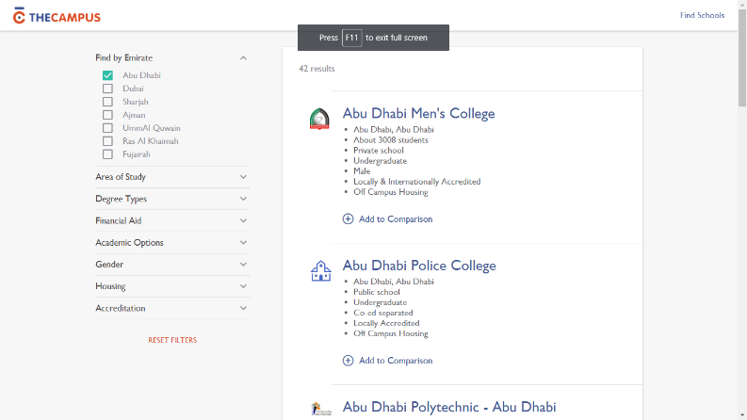
7 | Project Name | SAL-M
 | Project Position | Web Developer
 | Team size | 10
 | Project Description
 | Description | A cross-platform mobile chat bot application for reference of military aircrafts organization. Using voice recognition to convert speech to text and text to speech. Using AI service from API.AI to talk with users. Users can look up information of aircrafts.
 | Technical Environment
 | Framework | React Native
 | Development Tools | WebStorm, GitHub
 | Database | MongoDB
 | Programming language | JavaScript
8 | Project Name | Paychex (Equifax)
 | Project Position | Web Developer
 | Team size | 10
 | Project Description
 | Description | An internal system to manage information of huge companies to provide payroll service for employees. Providing web interface for manage rules and data for companies according to the contract between company and Equifax.
 | Technical Environment
 | Framework | Angular.js
 | Development Tools | Rubymine, JIRA
 | Database | Oracle
 | Programming language | JavaScript, Ruby
9 | Project Name | tuyenlaodongphothong.com
 | Project Position | Full-stack web developer
 | Team Size | 8
 | Project Description
 | Project Link | https://tuyenlaodongphothong.com
 | Description | Tuyenlaodongphothong.com is a platform deal with the problem of the companies: potential supplier for (blue) worker. Our platform will provide the solution for the companies to hire workers base on the requirement and location of the factories. For now, we are building a web application for employee (worker) and employer (company). Employee can find a good job. Besides that, recruiter from the companies can manage and review the applicant from the applicants through management dashboard.
 | Technical Environment
 | Technologies | React.js, Node.js (Loopback)
 | Development Tools | WebStorm, GitLab
 | Programming language | JavaScript
 | Images | 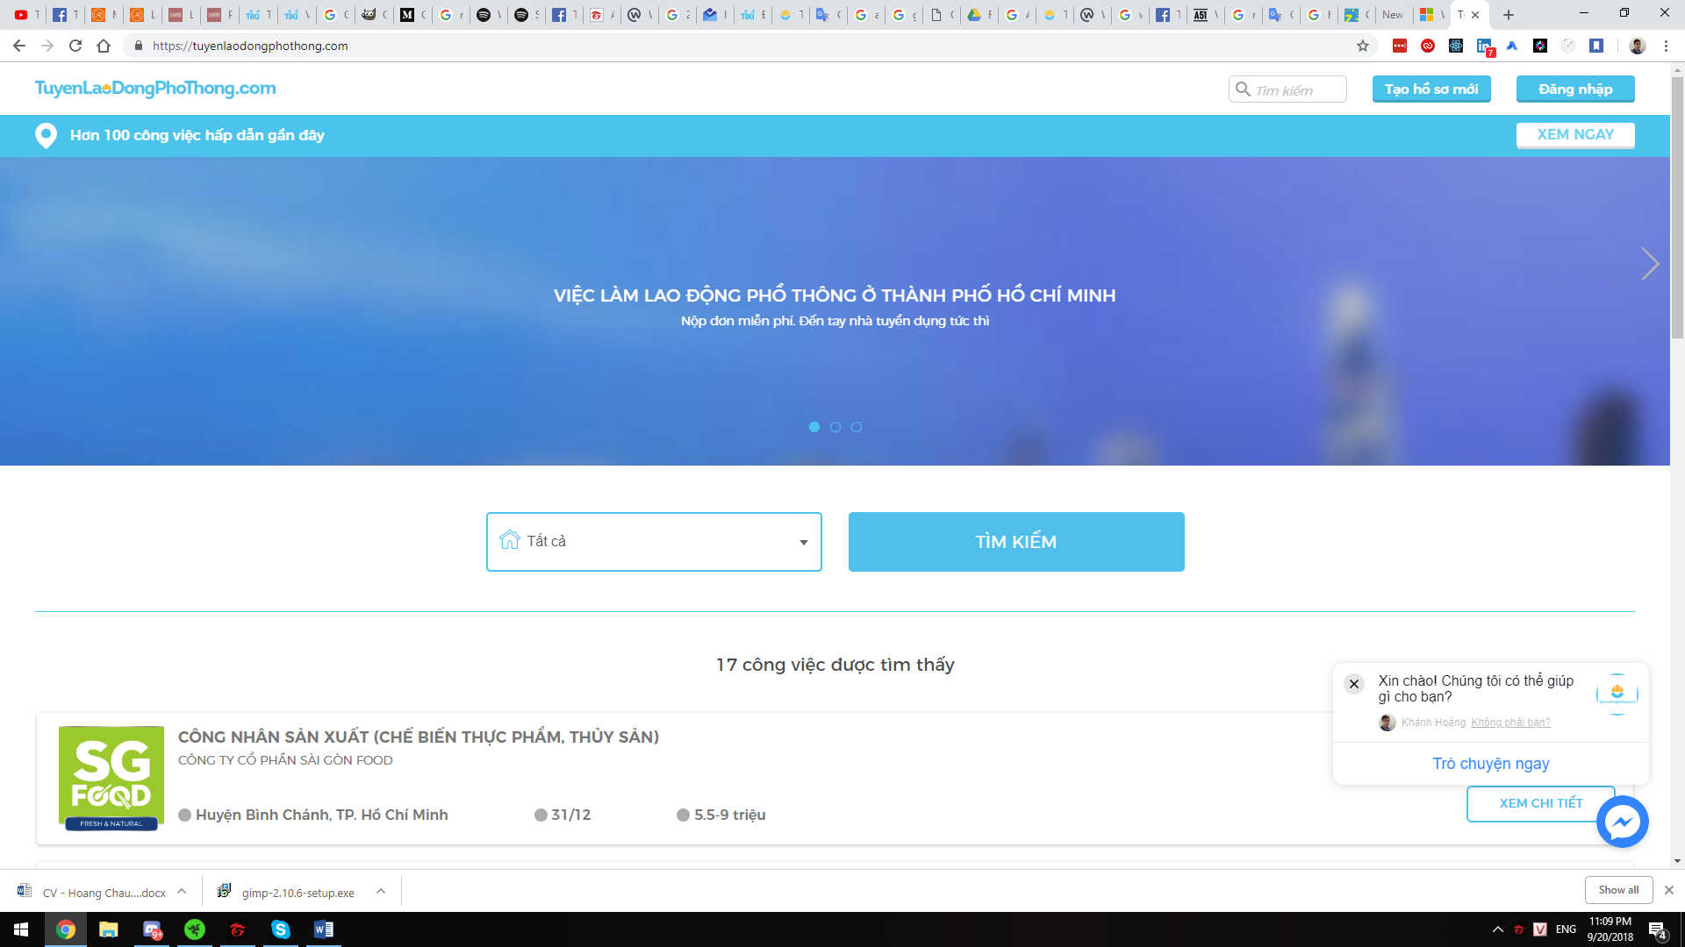  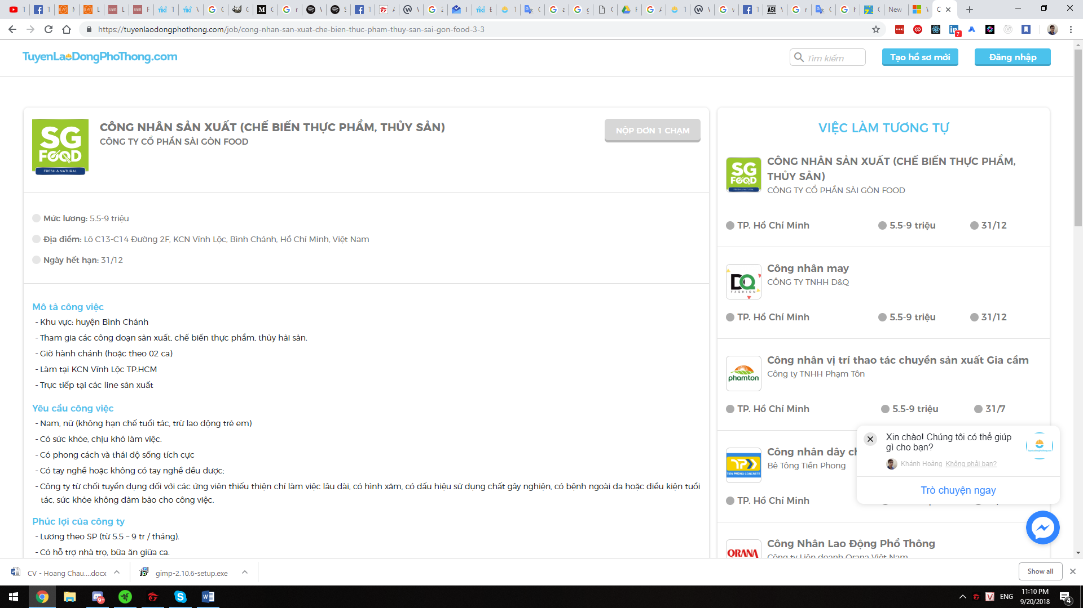

FREELANCER PROJECTS
No | Projects | Description
1 | Project Name | hoc247
 | Project Position | Manager
 | Project Description
 | Description | This is a requirement from a teacher. He needs an E-learning web application to sell courses by publish videos and documentations. Customer want to sell courses by paid phone cards. So, we need to integrate payment gateway for purchasing. Besides that, security is the second important point for a store. We need to make sure that all transactions from users to server are secured.  In this project, we focus on automation to enhance the workflow. Bamboo helps us deploy the app automatically without handwork.
 | Technical Environment
 | Technologies | Node.js, Vue.js
 | Development Tools | GitHub, JIRA, Bamboo, Confluence, Intercom
 | Database | MongoDB
 | Programming language | JavaScript
 | Images | 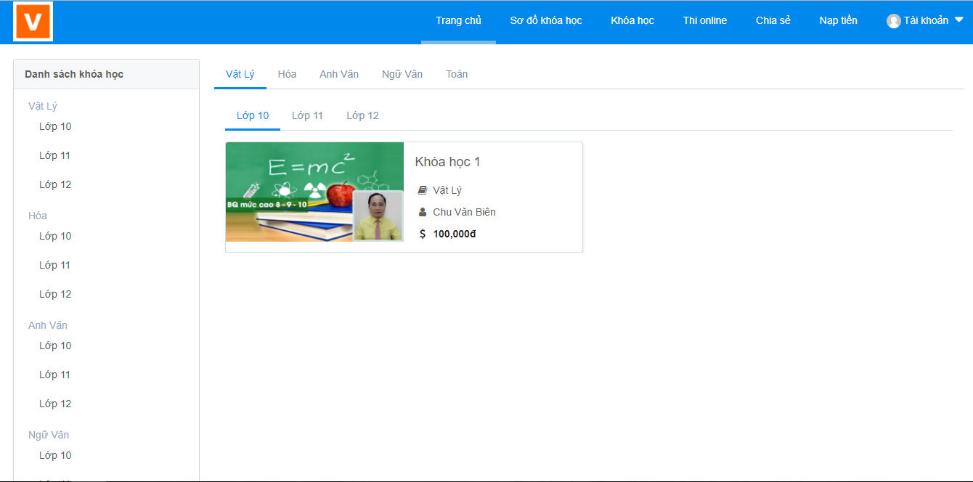
2 | Project Name | CMS Website
 | Project Position | Development for back-end and Web front-end
 | Project Description
 | Description | The customer need an administrator website for manage information and generate reports from customer’s server.
 | Technical Environment
 | Technologies | Node.js, Angular.js
 | Development Tools | Sublime, Git, GitLab
 | Database | MongoDB, AWS (VPS)
 | Programming language | Java, JavaScript

PET PROJECTS
No | Projects | Description
1 | Project Name | Bloggrails
 | Project Position | Development for back-end and web application
 | Project Description
 | Project Link | https://bloggrails.herokuapp.com
 | Description | A simple Ruby on Rails application for bloggers. User can post articles and leave comments. User can upload images for the article through Cloudinary service.
 | Technical Environment
 | Technologies | Web
 | Framework | Rails
 | Development Tools | WebStorm, GitHub, Cloudinary, reCAPTCHA
 | Programming language | Ruby, JavaScript
 | Images | 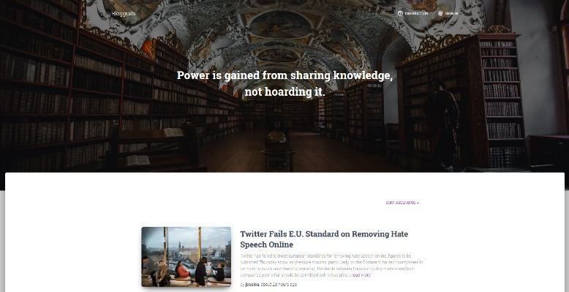
2 | Project Name | Games Searcher
 | Project Position | Development for back-end and web application
 | Project Description
 | Project Link | https://games-searcher.herokuapp.com
 | Description | This application uses the 3rd party services to get the game data and the best prices of these games on many game stores. User can search games by name and share the content on Facebook. Additional user can choose the currency to display instead of default USD currency.
 | Technical Environment
 | Technologies | Node.js, Web
 | Framework | Express (server), React.js (Web)
 | Development Tools | WebStorm, GitHub, Ant Design library, Facebook SDK
 | Programming language | JavaScript
 | Images | 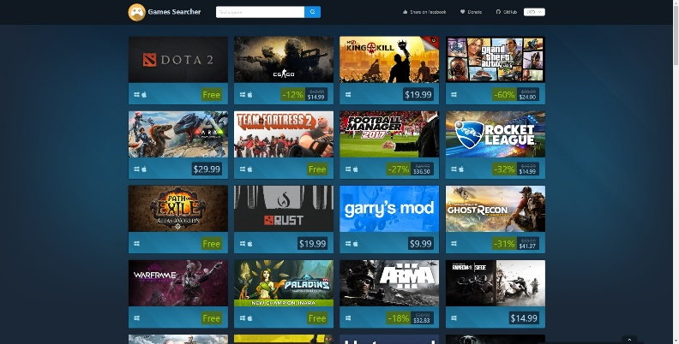
3 | Project Name | Chat App
 | Project Position | Development for Back-end and Android
 | Project Description
 | Description | User can register an account, login and chat with someone else in real-time. Account credentials are secured on the database of server. All connections from the clients to server must be authenticated and authorized to make sure the good security.
 | Purpose | Learn how to integrate Node.js with Android client to make the complete system.
 | Technical Environment
 | Technologies | Node.js, Android
 | Development Tools | Android Studio, Sublime, Fabric service
 | Database | MongoDB, Digital Ocean (VPS)
 | Programming language | Java, JavaScript
 | Images | 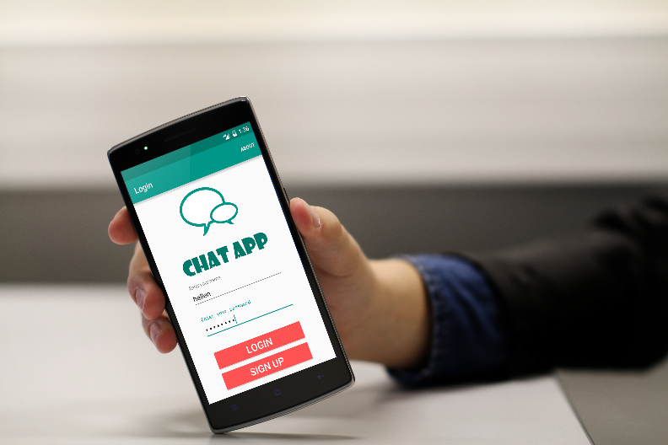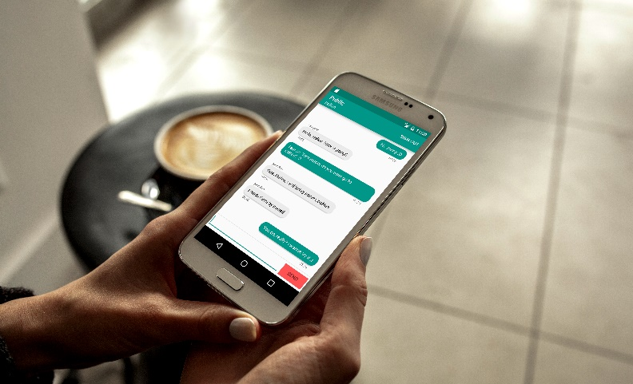
4 | Project Name | IMDB Top Movie
 | Project Position | Development for back-end and Android
 | Project Description
 | Project Link | https://github.com/hckhanh/imdb-top-movies
 | Description | Make an application can fetch information of the top 250 movies of IMDB. When user open the app, it will fetch data from server and show to the screen. User can load more movie by swiping down the list to load more data.
 | Purpose | Learn how to integrate Node.js with Android client to make the complete system.
 | Technical Environment
 | Technologies | Node.js, Android
 | Development Tools | Android Studio, Sublime
 | Database | MongoDB, Digital Ocean (VPS)
 | Programming language | Java, JavaScript

PROJECTS AT SCHOOL
No | Projects | Description
1 | Project Name | Make a note application
 | Project Position | Development
 | Team Size | 2
 | Project Description
 | Description | Make a note application on Android. User can save the notes from the current day and review them any time and any mobile devices they want.
 | Course | Mobile Programming
 | Technical Environment
 | Technologies | Android
 | Development Tools | Eclipse (ADT – Android Developer Tool), Dropbox API
 | Database | SQLite, Dropbox cloud storage
 | Programming language | Java
2 | Project Name | English pronunciation application for Android
 | Project Position | Team leader
 | Team Size | 10
 | Project Description
 | Description | Make the application on Android help people can practice English by using their phones. The user speaks out the word/word phrase refer to the picture on screen. The app can detect the voice and show the result to users and tell them what they said is right or wrong. Users can choose pictures from topics with 1000 picture and words/phrases
 | Course | Software Project Management
 | Technical Environment
 | Technologies | Android
 | Development Tools | Eclipse (ADT – Android Developer Tool), BitBucket, Google API
 | Database | SQLite
 | Programming language | Java

