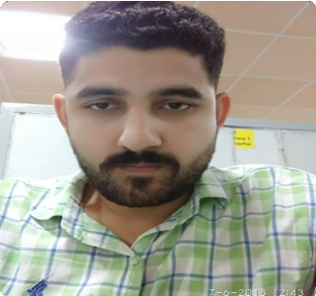
Ripesh Sadhu

House Number 25, Lane
CONTACT
Number 1, Sector 2
Laxmi Nagar , Muthi Jammu, J&K

E-mail:
Abhisheksadhu.sadhu@gmail.com
Phone: 7006457910

WORK EXPERIENCE

DIGITECH Systems & Infocom Pvt LTD January 2018 — Present
Hardware and Network Engineer
Working Under contractual basis in Powergrid Corporation of India Limited.

Sysinfocom 01-01-2017 — 30-07-2017
RHCSA
- Redhat certification (RHCSA)
- Badic Windows knowledge with basic knowledge of windows 2008 server

QUALIFICATIONS
B Tech ( CSE)

EDUCATION

B tech August 2012 — June 2016
Swami Devi Dyal Institute of Engineering and Technology

INTERESTS
Internet Browsing ,Exploring & Learning About Computers , Playing Pc Games, Watching Tv Shows

REFERENCES
References available upon request.

CERTIFICATION
- RHCSA

Key learning (operating system)
- Operate Window-7, window-8, window-10
- Operate Cent OS , Ubuntu 16.04 LTS
- Installation & troubleshooting of operating system
- Upgrade & restore the operating system and application configuration.
- Remote assistance TELNET & SSH

Key learning (Linux skills)
- Installation Linux OS
- Troubleshooting on hardware level.
- Installation and configuration of Linux
- Users, Group creation and modify it
- Password recovery
- Install yum service on server and client side
- Share and Access folders(NFS)
- Access directly to Linux Server(VNC)
- Access Linux to Linux(SSH), Windows to Linux(Samba)
- PC assembling.
- Formatting.
- Drivers configuration.
- Installation window-7, 8, 10
- DHCP
- FTP

Date: Ripesh Sadhu

