PERSONAL INFORMATION:
Full Name: Bùi Đình Đàn
Email: buidan.infotech@gmail.com
Phone: 038.280.4344

ABOUT ME:
- Enjoyed with learning, research new technologies and new platforms.
- Having organizational mind set and high teamwork spirit in coordinating and supporting other colleagues.
- Over 10 years experience in web/app development and management.

EDUCATIONAL BACKGROUND:

- 8/2012 - Graduated with excellent level at Faculty of Information Technology, Ho Chi Minh City University
- Repeatedly got scholarship in the academic years at the University

SKILLS:
- Strong experience with PHP, NodeJS and web development.
- Strong experience using Dart and Flutter to build beautiful and rapidly mobile application.
- Experience in manage team around 5 - 12 members.
- Good communication in English and Vietnamese.
- Experience in providing solution and architectural blueprints to team from requirements.
- Practical experience building micro-service system
- Practical experience with CI/CD
- Great practical experience with cloud (AWS, GCP, Azure)
- Experience with big data and big traffic system.
- Practical experience with containers (Docker, Kubernetes, ...)
- Practical experience in review code of team members and make comment to improve quality.
- Solid knowledge of end-to-end web development using PHP, OOP and MVC architecture and MySQL, NoSQL.
- Experience with service-oriented backend architectures (SOA)
- Experience with almost Php frameworks (Laravel, Yii, Ci, Cakephp, Zend, Phalcon …)
- Practical experience with Nodejs, websocket, WebRTC
- Practical experience with Test Driven Development (TDD), Unit Test, Automation Test, Performance Test.
- Experience with Linux administration
- NoSql Expert such as (Mongodb, Redis, Couchbase)
- Practical experience building api using Restful web service or SOAP
- Experience working with payment, banking system.
- Practical experience with searching technology such as Elasticsearch, sphinx.
- Experience with agile software development methodologies like Scrum, Kanban
- Database design and optimize mysql sql queries to improve performance
- Source control systems such as SVN, CVS, GIT
- Client and server-side performance optimisation techniques
- Solid knowledge of standards-based, accessible, cross-browser web development
- E-commerce / Payment Gateway integration
- Experience of development throughout the product life cycle from a performance point of view
- Writing clear documentation
- Experience with Python and Django framework
- Good understand about other languages such as: Golang, Java, C#, C++
- Good understand about Android/iOS applications
- Fast in troubleshooting/Bug fixing
- Willing to explore and learn new things and a good attitude

WORKING EXPERIENCE:

I have more than 10 years of experience working as a developer / manager.

Period | Company | Role
05/2010 to 05/2012 | Netbiz consulting | PHP/NodeJS Developer
05/2012 to 09/2013 | VNP | Backend Leader
09/2013 to 10/2016 | HOCMAI | Head of R&D department
10/2016 to 1/2019 | HOTTAB | Teachnical Team Leader
From 1/2019 | S.A.M. Financial Group | Team Leader

Below are some of my recent websites and mobile applications:

Nailsmap
Description | Online beauty services booking system
Team size | 5
Duration | ~ 12 months
Role | Tech Lead / Flutter app developer / Backend Developer
Responsibilities | - Design system overview and user cases  - Design backend api list from requirements  - Design database  - Build Flutter app  - Implement api  - Review code  - Create CI/CD
Technologies used | Flutter, Laravel, Mysql, Redis, AWS
Links | https://nailsmap.com/
Some app screens | 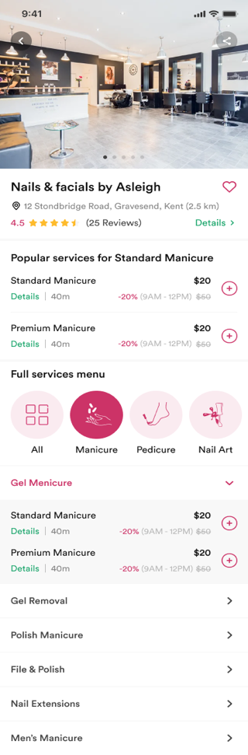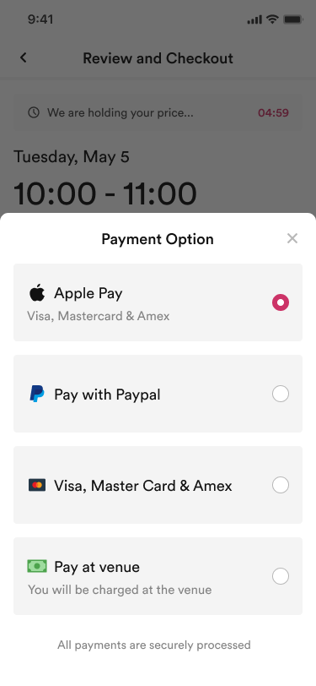
Nailsmap SO
Description | App allow Salon owner manage online order, staff and invoice…
Team size | 5
Duration | ~ 12 months
Role | Tech Lead/ Flutter app developer / Backend Developer
Responsibilities | - Design system overview and user cases  - Design backend api list from requirements  - Design database  - Implement api  - Build Flutter app  - Review code  - Create CI/CD
Technologies used | Flutter, Laravel, Mysql, Redis, AWS
Links | https://nailsmap.com/
Some app screens | 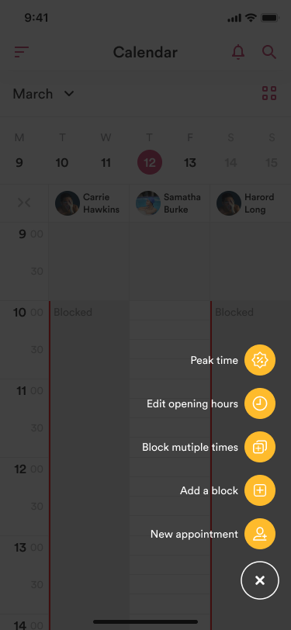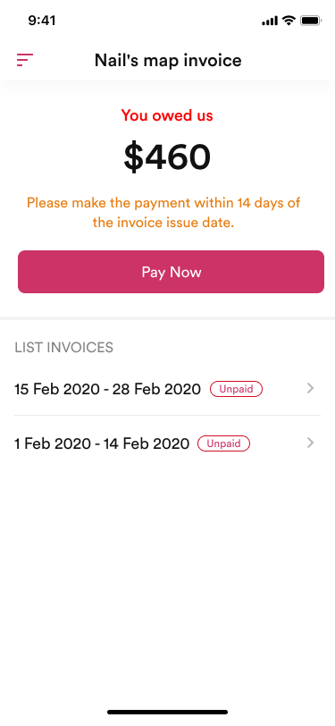
Hottab POS
Description | POS system to allow waiter or customer can order foods at restaurants or hotels
Team size | 6
Duration | ~ 2 years
Role | Backend Lead / Backend Developer
Responsibilities | - Design backend api list from requirements  - Design database  - Implement api  - Review code  - Create CI/CD  - Create reporting system
Technologies used | Laravel, Java, NodeJS, MongoDB, Mysql, Redis
Links | https://hottab.net/
Sopa Consumer
Description | Food online ordering system, allow customer make order online, pay online then deliver the order to the customer
Team size | 5
Duration | ~ 12 months
Role | Backend Lead / Backend Developer
Responsibilities | - Design system overview and user cases  - Design backend api list from requirements  - Design database  - Implement api  - Review code  - Create CI/CD
Technologies used | Laravel, NodeJS, ReactNative, ReactJS, Mysql, Redis
Links | https://sopa.asia/
SamtradeFX
Description | Forex Broker, allow forex users can manage account, transactions, deposit, withdraw money.
Team size | 5
Duration | ~2 years
Role | Flutter App developer/ Backend Lead
Responsibilities | - Wrote Flutter app from scratch  - Build Academy system from scratch  - Build Trading Copy system from scratch  - Implement api  - Build academy website  - Review code  - Create CI/CD
Technologies used | Flutter, Laravel, C++, VueJS, Mysql, Redis, Elasticsearch, Wordpress
Link | https://www.samtradefx.com/
Some app screens | 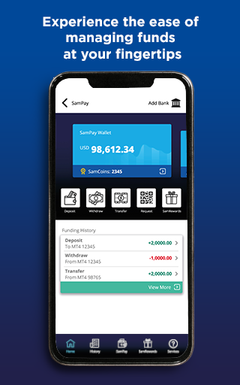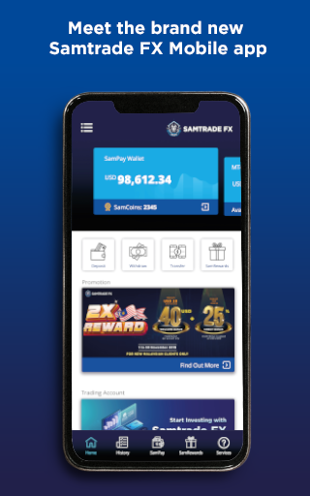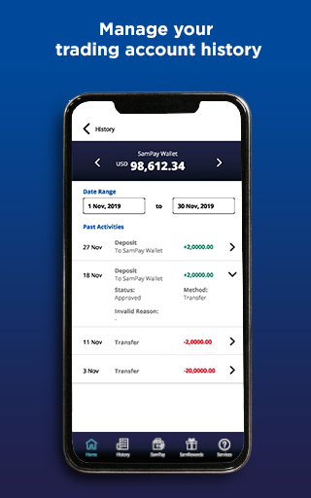
HOCMAI.VN
Description | Online learning services with online college review, exam preparation, and mock exam programs for high school, middle school and elementary school students.
Team size | 10
Duration | ~ 2 years
Role | Head Of R&D Department
Responsibilities | - Research and develop new products & technologies  - Design system overview and user cases  - Design system requirements  - Work with team in order to release new products and new features on time.
Links | https://hocmai.vn/
Payday Ventures Limited
Description | Financial lead generation network focusing on personal finance in Australia, Europe and USA.
Team size | 4
Duration | ~ 2 years
Role | Tech Lead / Backend Developer
Responsibilities | - Design system overview and user cases  - Design backend api list from requirements  - Design database  - Implement api  - Implement front-end sites  - Connect with short loan partners and debt partners api  - Handle admin site to manage the system  - Review code  - Create CI/CD  - Handle load balancer and scale up system
Technologies used | PHP, Yii2, Wordpress, AWS, MongoDB, Mysql, Redis
Links | https://verymerryloans.com/ , https://www.vivapaydayloans.com/ , https://www.vivaloans.co.uk/ , http://loanmr.co.uk/ , https://bluesealoans.co.uk , https://www.creditraters.com , https://heartpaydays.com , https://debtnurse.co.uk , https://www.moneylendersquad.com/ , https://rapidloans.co/ , https://www.creditclock.net , ….
zistemo.com
Description | tool that simplifies business management, attendance and project time tracking / timesheet approval and smart invoicing altogether.
Team size | 8
Duration | ~ 1 year
Role | Senior Backend Developer
Responsibilities | - Implement api  - Implement front-end side  - Review code  Handle load balancer and scale up system
Technologies used | PHP, Yii2, AWS, MongoDB, Mysql, Redis
Links | https://moneypenny.me or now is https://zistemo.com/

