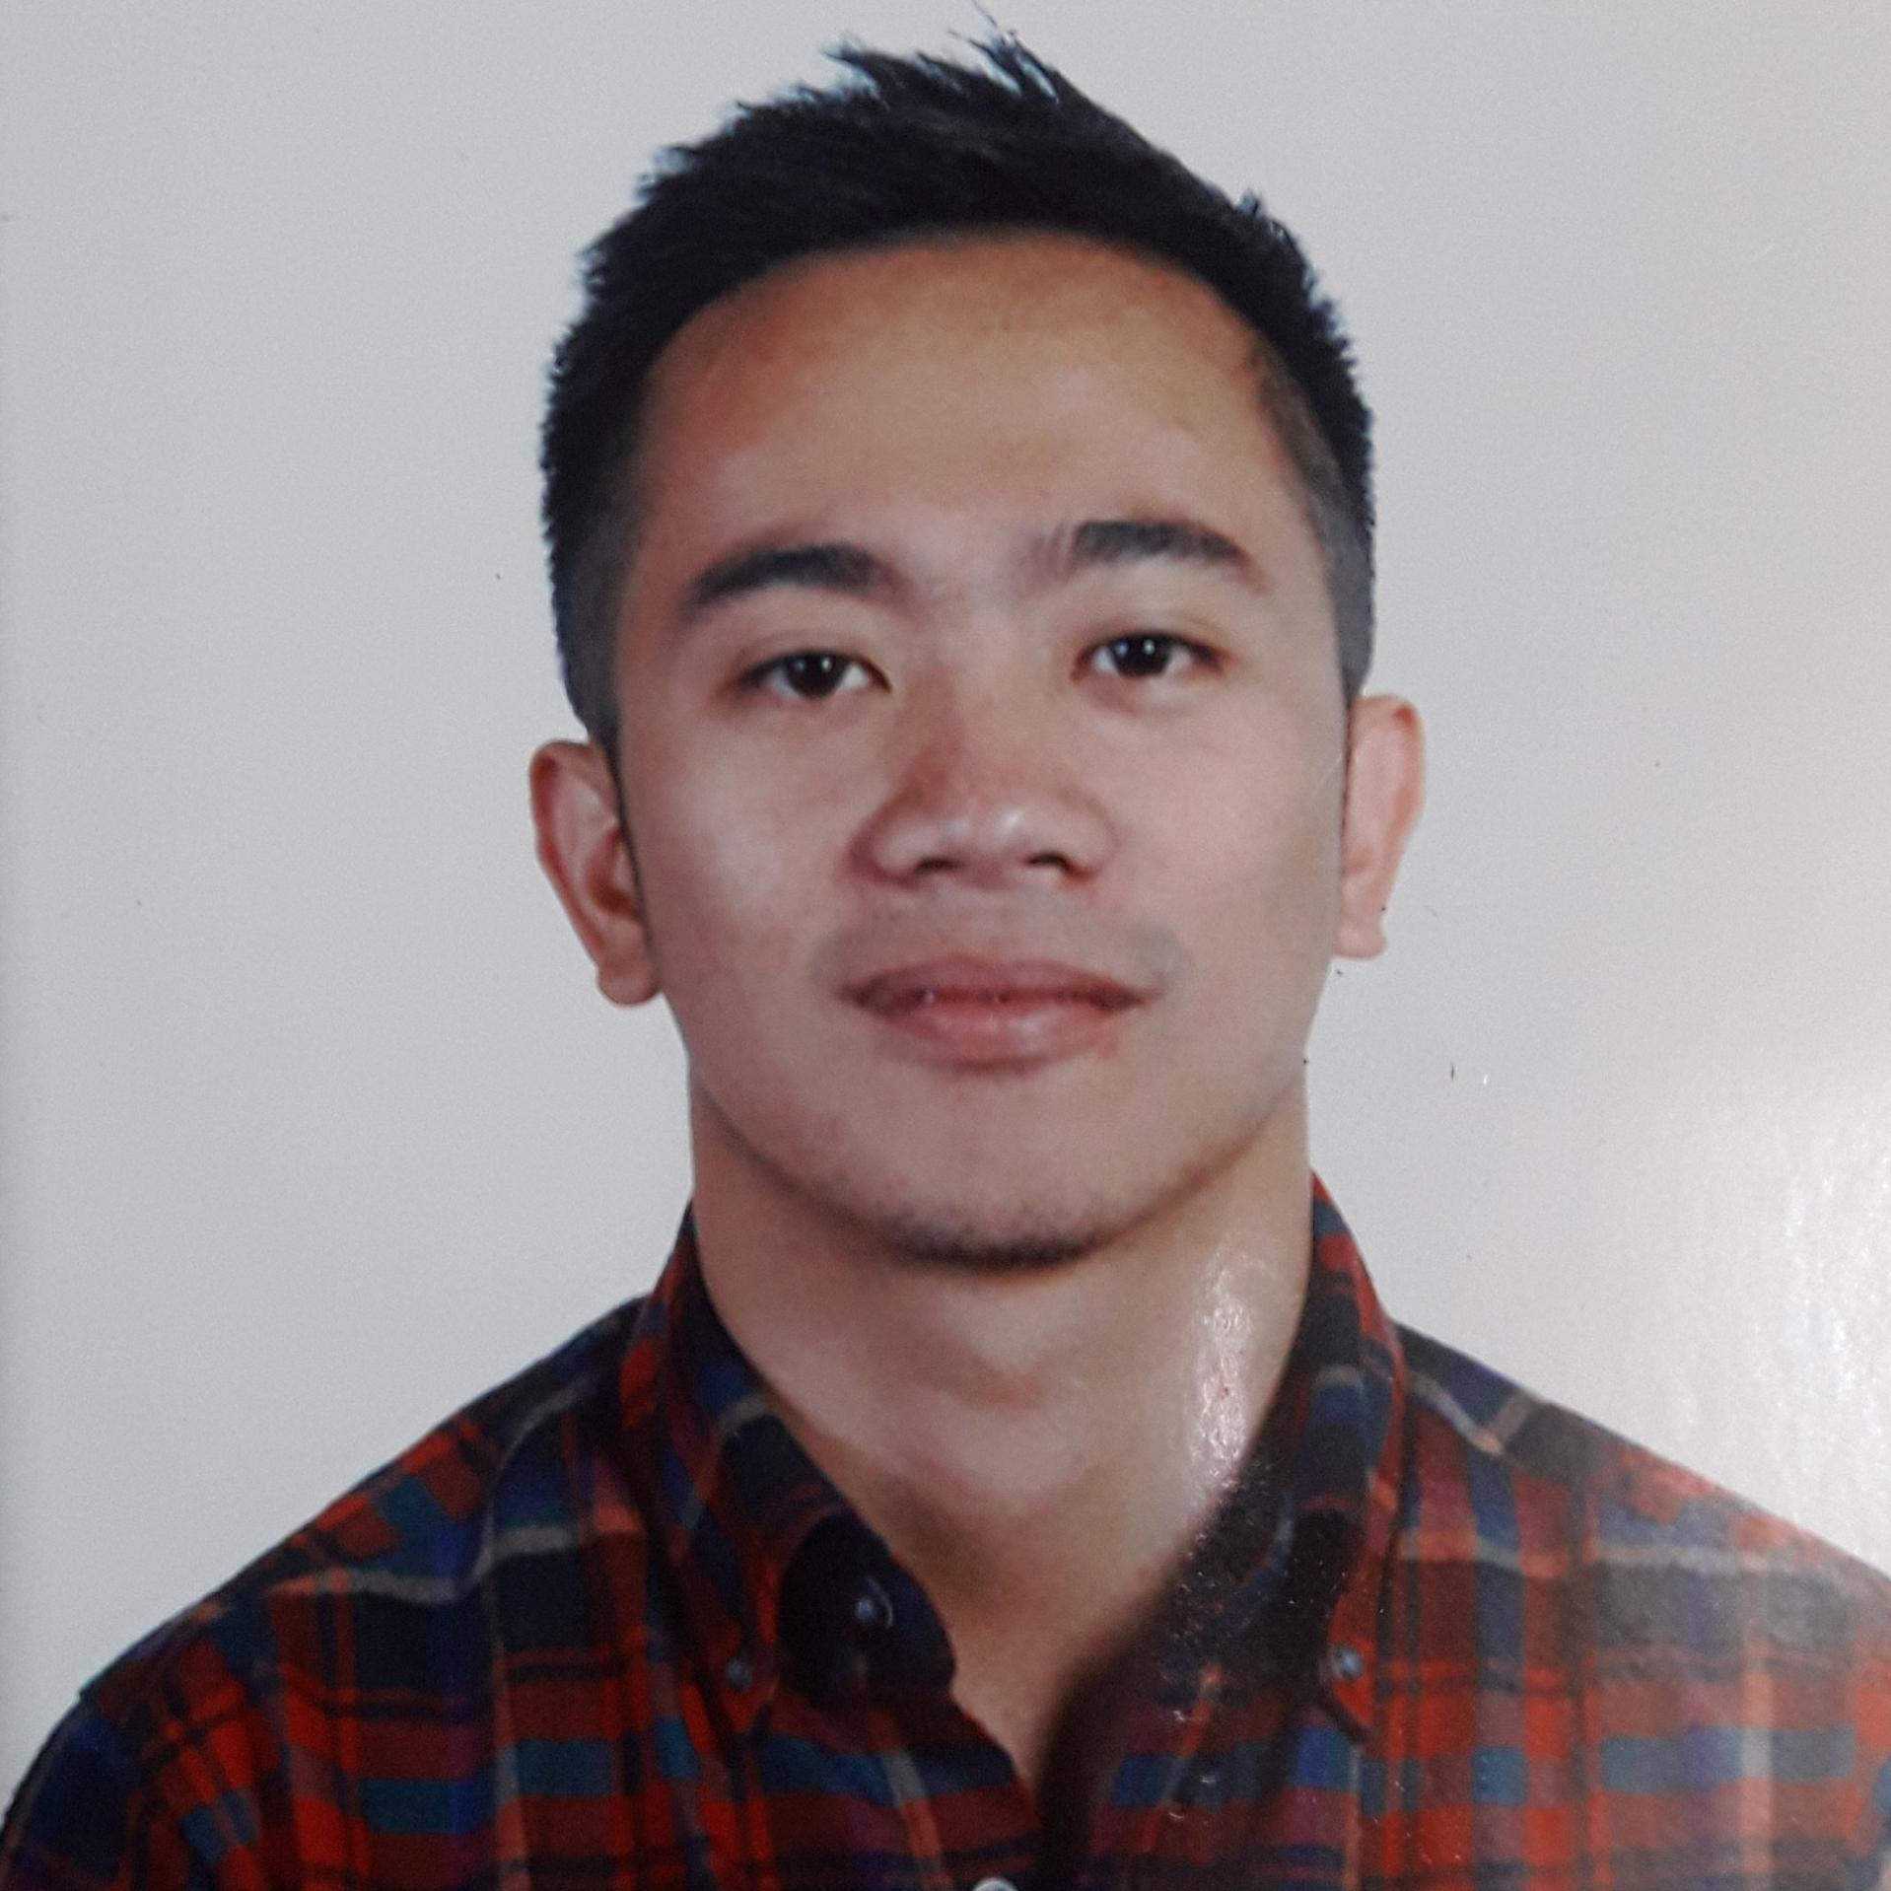
Carl Carambas

Mobile: 09178746354
Email: ph.developers@sunmoontechnologies.com

HIGHLIGHTS
8 years experience in Information Technology, 3 years Java/J2EE, Android Studio development experience, 3 years technical support experience, 3 years software engineer experience, 3 year full-stack developer.

- Strong communication and interpersonal skills.
- Strong technical problem solving skills.
- Experience and been involved in all phases of the software development from planning and data gathering, development and testing, to the implementation and maintenance.
- Solid Experience in AngularJS, 4, 5, 6 front-end Development
- Experience using React.js for front-end Development
- Experience with different operating systems including Windows, Linux, Mac OS X.
- Solid Experience with relational database including MyQSL and MSSQL.
- Experience on NoSQL such as MongoDB.
- Solid Experience in NodeJS Express API Development.
- Experience on Continuous Integration and Development and Docker and Webpack.

EXPERIENCE
Sept 2018 - Current • Spanda
Freelance
Full Stack Developer

Duties and Responsibilities:

- Developed RESTFUL API for mobile app using Node JS Express
- Created and deployed applications AWS EC2 and RDB instances
- Maintained and developed internal administrator site written in ReactJS, GraphQL and GoLang

July 2016 - Sept 2018 • Twistresources, INC.
Berthaphil III - Clark, Pampanga
Developer
Duties and Responsibilities as a Developer:

- Work with Agile Software Development.
- Analyze, Design, document and deliver software features based on requirements
- Responsible in designing and developing Web API using NodeJS Express
- Formulated processes based on the requirements set by the clients.
- Responsible for bug fixing web application issues.
- Participate in daily scrum and other technical meeting.
- Presentation/demo the functionality of the system/component to the clients.

November 2014 - July 2016 • Bryegu Web Designs
Android/Mobile Developer
Responsible in developing mobile application basing the design and functionalities from a web based application using Java and XML for Android Studio; HTML, CSS, AngularJS for Cordova and other multi-platform framework such as Ionic.

EDUCATION
Saint Louis University - Baguio City, Philippines (2007 – 2012)
• Bachelor of Science in Information Technology

SKILLS

Proficient | Javascript, TypeScript | Intermediate | Docker, Docker-compose
Proficient | NodeJS Express | Intermediate | GraphQL
Advance | ReactJS, Angular | Intermediate | AWS (S3, ELB, EC2, RDS)
Advance | Java, JSP | Intermediate | CICD / yml files
Advance | jQuery | Intermediate | Flutter
Advance | MySQL, NOSQL | Intermediate | C#
Intermediate | GraphQL | Intermediate | Swift 4/Objective C
Intermediate | AWS (S3, ELB, EC2, RDS)

PROJECTS

Spanda (Mobile App) - https://play.google.com/store/apps/details?id=client.spanda.com
Part: Backend
Front-End: Android, iOS Native
Backend: NodeJS Express
DB: MySQL

Spanda Website - https://spandamobileapp.com/
Part: Front-End
Front-End: ReactJS

Spanda Admin V1 - (N/A)
Part: Full-Stack
Front-End: Angular
Back-End: GoLang, GraphQL
DB: MySQL
Studylane - https://globalstudypartners.com/
Part: Front-end, Back-end
Front-End: Angular 1
Back-End: NodeJS Express - Java (Internal Framework)
DB: MySQL
Forms Express - https://www.enotices.com.au/
Front-End: JSP, JQuery
Back-End: Java (Internal Framework)
DB: MySQL
NutraOrganics - https://www.nutraorganics.com.au/
Front-End: JSP, JQuery
Back-End: Java (Internal Framework)
DB: MySQL

